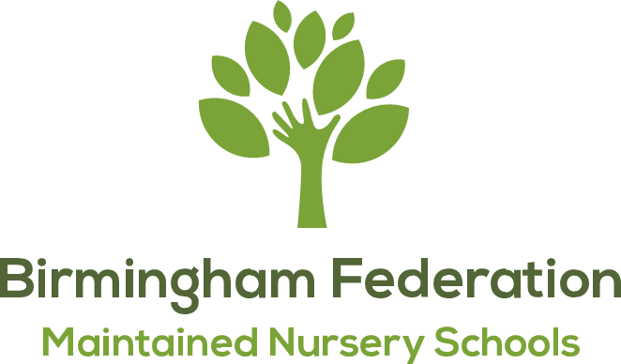

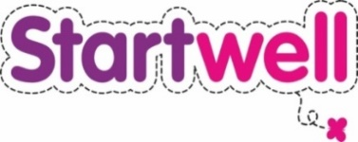
Drinks Policy

Allens Croft Nursery School

Aim of this Policy
To provide fresh milk and plain drinking water. Diluted fresh fruit juice may be offered to children at meal times. The children throughout the day have access to fresh water in all our provisions.

Objectives
- To reduce intake of sugar in children’s diet to prevent tooth decay and excessive weight gain
- To prevent poor speech and language development which can be caused by inappropriate use of drinking vessels and tooth decay
- To encourage a happier and calmer population of children

Support & Guidance
This policy was formed with support from Startwell. Their guidance is based on Public Health England Early Years Menu guidelines which produce evidence-based guidelines for nutrition for under 5’s.

Role Models
- All staff will act as good role models for children and will only have water bottles that contain water in all the nursery provisions.

Water
- Birmingham tap water is fluoridated to protect enamel on teeth, therefore, we provide fresh tap water
- Water will be freely available throughout the day
- Each room has a water station with water jugs and cups
- Water jugs and cups are provided on dining tables at meal times

Diluted Fruit Juice
Where children are offered fresh fruit juice, the NHS guidance is to dilute the fruit juices with water (1 part juice to 10 parts water) and offer with a meal in an open cup/ free-flow beaker to avoid tooth decay.

Milk
Children (2 years and older) are provided with semi-skimmed milk. Milk is offered at morning or afternoon snack time

Drinks from Home
Drinks from home are not permitted in nursery with the exception of:
- breast and formula milk
- reasonable adjustments made for children with SEND/ medical needs

Drinking Vessels
- Unlidded cups are provided by our nursery
- Bottles are not permitted in nursery (we understand that reasonable adjustments may need to be in place for children with SEND / medical needs)
- Milk cartons with straws
- None-spill beakers are not permitted in nursery.

Monitoring
All staff are responsible for monitoring this policy. Unsuitable drinks and drinking vessels will be returned to parents.

Date Policy Adopted:
Full Governing Body: 18.09.2023
Date for next renewal: Autumn Term 2025

Signed: _________________________
Chair of Local Committee

Signed: _________________________
Chair of Governors

Signed: _________________________ David Aldworth
Executive Head Teacher

